Ormiston Academies Trust

(Academy Name)  
Procurement Card policy

Policy version control

|  |  |
| --- | --- |
| Policy type | Mandatory |
| Author | Claire Lovell, Head of Compliance and Reporting |
| Approved by | Joanne Dawson, National Director of Finance |
| Release date | August 2022 |
| Review | Policies will be reviewed in line with OAT's internal policy schedule and/or updated when new legislation comes into force |
| Description of changes | 2.1 Reference change to Academy Trust Handbook.  4.4 Comment added to state that only the procurement card holder should use the card.  5.1.3 Comment added to state that Where possible the online statement should also be reviewed at least once prior to the monthly statement review.  5.1.6 Comment added to state that The Finance Director should review all transactions and authorise all transactions for any procurements cards held by the Principal, and the Principal should review all transactions and authorise all transactions for cards held by the finance team, ensuring segregation of duties is maintained at all times.  5.4 Comment added to state that The head office finance team will also remove the individual from the procurement card listing to ensure that it is up to date.  5.5.4 Comment added to state that The procurement card holder should also not allow another individual to use the card.  7.1 Comment added to state that Payments are now made from the Head Office bank account and coded to the academies multipay control account centrally.  10.1 Comment added to state that As part of the work undertaken by Internal Audit each year, spot checks will be carried out on procurement cards to ensure that the correct process, in line with this policy is being followed.  Flow diagram has been amended to change the line of reporting and to include the Head of Compliance and Reporting and the extract has been updated to the Academy Trust Handbook 2021. |

Contents

1. Introduction 4

2. Objectives 4

3. Scope 4

4. Card issue 4

5. Cardholder’s responsibilities 5

5.1. The cardholder shall: 5

5.5. The cardholder shall not: 6

6. Procurement card expenditure 6

7. Payment of procurement cards 7

8. Procurement card misconduct 7

9. Procurement card fraud 7

10. Monitoring controls 7

Appendix A 8

Procurement card flowchart 8

Appendix B 9

Fraud flowchart 9

1. Introduction
   1. This policy provides guidance on when Corporate Procurement/Purchasing Cards may be issued, and how they should be used.
2. Objectives
   1. The objectives of the OAT Policy are:

* To provide clear guidance on the issue and usage of Company Procurement/Purchasing Cards (“procurement cards”)
* To ensure that procurement card usage is compliant with the requirements of the Academy Trust Handbook

1. Scope
   1. The Policies and Procedures apply to all employees of OAT.
2. Card issue
   1. A Corporate Purchasing Card facility is available which is linked to the Trust’s banking facility. The OAT head office finance team act as administrators of the procurement card facility.
   2. Procurement cards may only be issued to named individuals, and applications must be authorised by the OAT finance team.
   3. The OAT head office finance team maintain a list of pre-approved card limits which reflects the needs of different roles. The Head of Finance is able to authorise the issue of a new procurement card, or a change in card limit, subject to these pre-approved limits. Authorisation from the National Director of Finance is required where the requested limit exceeds the pre-approved amounts. The Head of Finance and National Director of Finance will review the card limits periodically to ensure that they remain appropriate.
   4. The cardholder is responsible for all expenditure made using the procurement card, and it is only the procurement card holder that should use the card. Procurement limits will be issued based on the needs of the applicant, and if the procurement is required for a specific reason (e.g. expenditure during a school trip) the procurement limit will be removed when no longer required. The procurement card will remain valid, and if the procurement facility is required at a future date, this request must be approved by the Academy Finance Director and passed to the OAT finance team for processing.
3. Cardholder’s responsibilities
   1. The cardholder shall:
      1. In all cases obtain and retain sufficient supporting documentation to validate the expense (e.g. tax invoice) or shall in lieu provide a statutory declaration.
      2. Attach these to the monthly procurement card claim form/statement from the bank.
      3. Review the monthly statement for inaccuracies (and report these to the local finance team). Where possible the online statement should also be reviewed at least once prior to the monthly statement review to confirm that all transactions are genuine.
      4. Verify that goods and services listed were received.
      5. Sign the monthly procurement card claim form/statement to verify that transactions have been made for official purposes.
      6. Forward the papers to the authorised signatory for approval – procurement card claims should be authorised by the line manager and by the finance team. The Finance Director should review all transactions and authorise all transactions for any procurements cards held by the Principal, and the Principal should review all transactions and authorise all transactions for cards held by the finance team, ensuring segregation of duties is maintained at all times.
      7. Take adequate measures to ensure the security of the card.
      8. Be personally liable for any unauthorised transaction unless the card is lost, stolen or subject to fraud on some part of a third party.
   2. The cardholder must notify the card provider, the local finance team and the OAT finance team immediately and in accordance with Appendix A if:
      1. The card is lost or stolen;
      2. Any unauthorised transaction is detected or suspected.
      3. Any change in name or contact details.
   3. The cardholder shall inform the OAT finance team if:
      1. The cardholder leaves;
      2. The Academy Finance Director, Principal or OAT Executive team determines that there is no longer a need for the cardholder to retain his or her card;
      3. The procurement card has been cancelled by the card provider.
   4. The OAT head office finance team will cancel the procurement card. The cardholder must return the card to their local finance team who should destroy the card. The head office finance team will also remove the individual from the procurement card listing to ensure that it is up to date.
   5. The cardholder shall not:
      1. Exceed the procurement limit as set for the procurement card.
      2. Claim double allowances (i.e. request reimbursement for an expense already paid by the card).
      3. Purchase alcohol on the procurement card.
      4. Allow another individual to use the card.
4. Procurement card expenditure
   1. Procurement cards must only be used for business (not personal) expenditure. The procurement card will only be used for those activities that are a direct consequence of the cardholder’s function within the company.
   2. Where coincidental and/or private expenditure occurs on the same transaction (where, for example, a person incurs a debt for personal telephone calls during a hotel stay) the cardholder must settle the private expense prior to charging the balance on the procurement card. Where doubt exists as to whether or not an item is function-related, prior authorisation should be obtained from the finance team.
   3. The use of the procurement card for “services of a dubious nature” is expressly prohibited. “Services of a dubious nature” are defined as any goods or services that might bring the name of the organisation into disrepute.
   4. The use of procurement cards to withdraw cash advances is not permitted, and by default the cards are not authorised for use at ATMs. The only exception to this is in an emergency on an overseas trip, as shown in 6.5.
   5. All trip spend should be on a procurement card in the name of one of the trip leaders. Academies should plan ahead to order cards in sufficient time, with appropriate limits which will include contingencies for accidents etc. Cash can be withdrawn on Multipay cards in emergency situations only on overseas trips. Receipts must be provided to support how the total amount of cash withdrawn has been spent.  Any discrepancies will be deducted from the cardholder via payroll.  The use of cash is permitted in emergency situations only, due to the administrative burden of properly recording such expenditure
5. Payment of procurement cards
   1. Payment of procurement cards will be made each month by direct debit from the Head Office bank account and coded to the relevant academy’s multipay control account by the central finance team.
6. Procurement card misconduct
   1. Wherever a breach in this policy occurs, this must be reported to the Head of Finance and the National Director of Finance who must assess the nature of the breach and if significant report the breach to the police for criminal investigation or if lesser in nature, institute an appropriate disciplinary process.
7. Procurement card fraud
   1. Where fraudulent transactions are identified (relating to unauthorized third-party use of the card, which is not covered by section 8 above), the fraud flowchart in Appendix B should be followed.
8. Monitoring controls
   1. As part of the internal work undertaken each year spot checks will be carried out on credit card transactions to ensure that the correct process, in line with this policy is being followed.

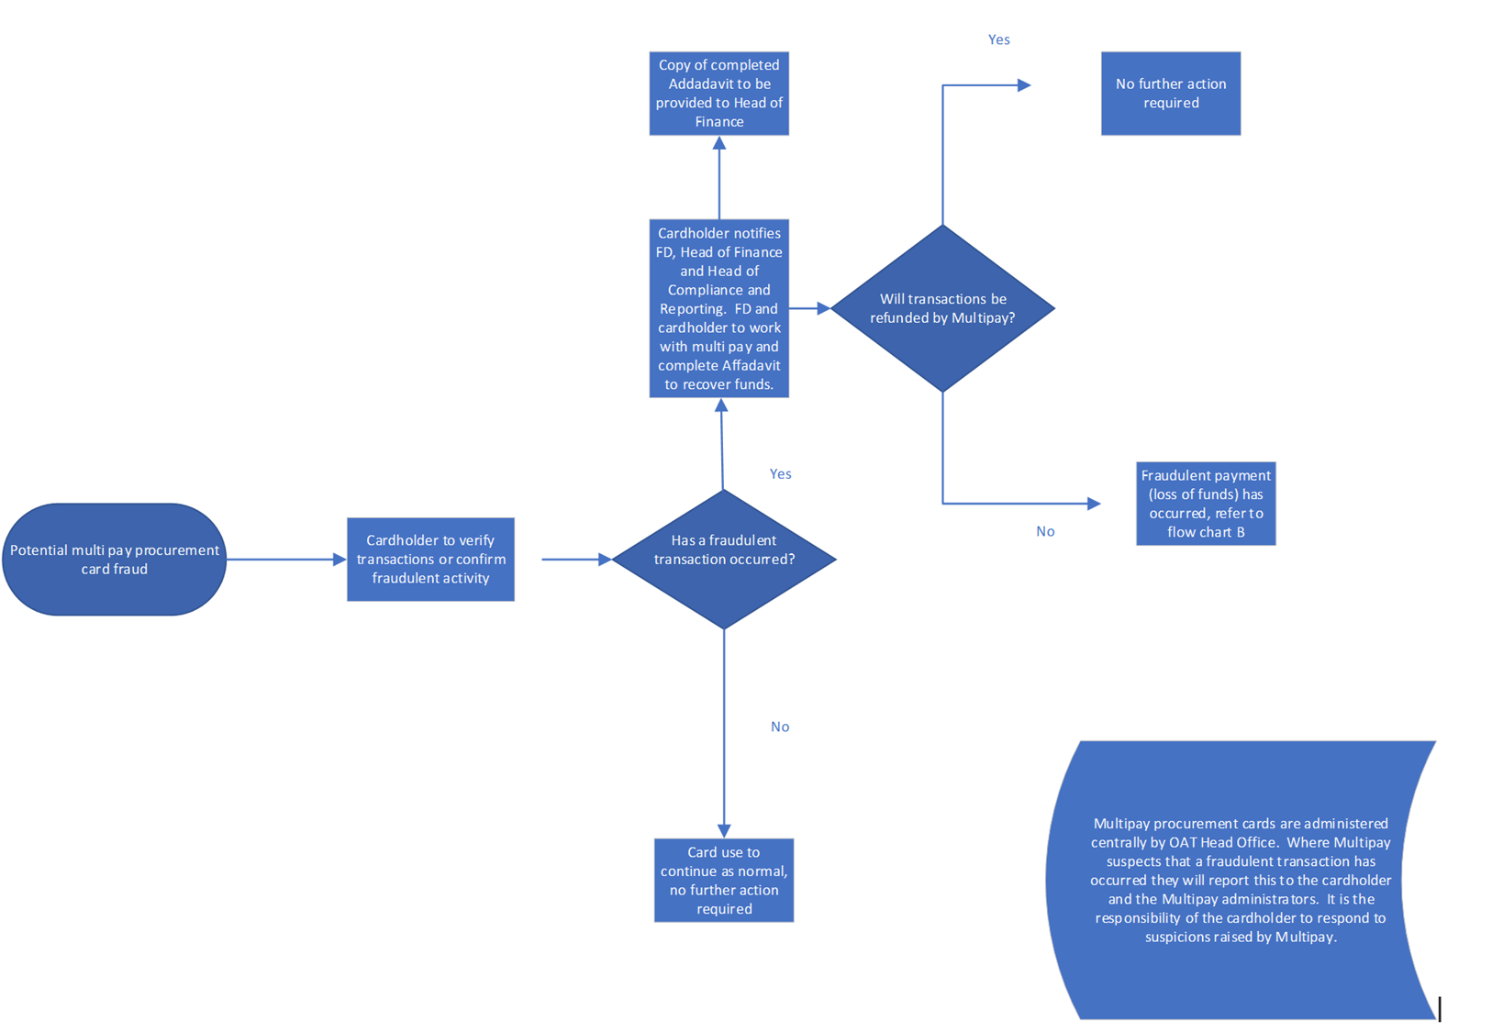Appendix A

Procurement card flowchart

Appendix B

Fraud flowchart

